Lab No | 8
Name | Noor Fatima
Reg No | 23_NTU_CS_1083
Semester | BSCS(6thA)
Subject | Web Development
Submitted to | Sir Abdul Basit
Submission Date | 17_03_2026


Computer Science
National Textile University Faisalabad

Lab NO 8

Question. No.1
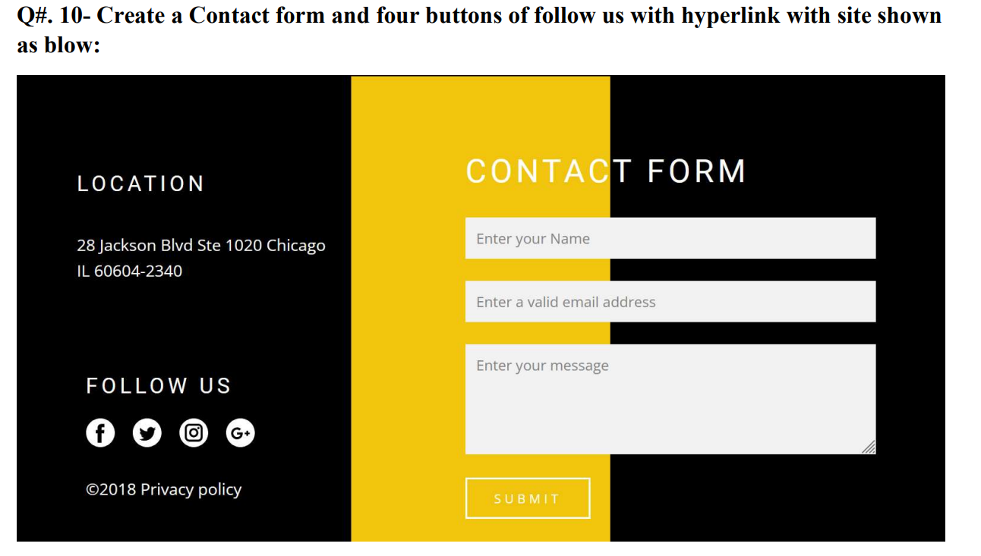
Code:
<!DOCTYPE html>
<html lang="en">
<head>
<meta charset="UTF-8">
<meta name="viewport" content="width=device-width, initial-scale=1.0">
<title>Contact Form</title>
<script src="https://cdn.tailwindcss.com"></script>
</head>
<body class="m-0 p-0 overflow-hidden">

<!-- WRAPPER - position relative so form can be absolute inside -->
<div class="relative flex h-[600px]">

<!-- LEFT BLACK PANEL (35%) -->
<div class="w-[35%] bg-black text-white">

<p class="mt-[20%] text-center text-3xl font-bold">Location</p>
<p class="mt-[5%] text-center text-lg">28 Jackson Blvd Ste 1020 Chicago</p>
<p class="mt-[5%] text-center text-lg">IL 60604-2340</p>

<p class="mt-[15%] text-center text-3xl font-bold">Follow Us</p>
<img src="logos.png" alt="facebook" class="mt-[5%] block mx-auto"/>

<p class="mt-[5%] text-center text-lg">&copy; 2018 Privacy Policy</p>

</div>

<!-- MIDDLE ORANGE PANEL (30%) -->
<div class="w-[30%] bg-yellow-500"></div>

<!-- RIGHT BLACK PANEL (35%) -->
<div class="w-[35%] bg-black"></div>

<!-- FORM - absolute on top, same as original margin-top:120px margin-left:700px -->
<form class="absolute top-[120px] left-[700px] text-white">

<h1 class="text-3xl font-bold mb-4">Contact Form</h1>

<!-- Name -->
<input
type="text"
name="Name"
placeholder="Enter Your Name"
class="w-full h-[25px] px-2 mb-4 bg-transparent border border-[rgb(189,249,229)] text-white placeholder-white outline-none"
/><br/><br/>

<!-- Email -->
<input
type="email"
name="Email"
placeholder="Enter Your valid Email"
class="w-full h-[25px] px-2 mb-4 bg-transparent border border-[rgb(189,249,229)] text-white placeholder-white outline-none"
/><br/><br/>

<!-- Message -->
<textarea
name="Message"
rows="6"
cols="40"
placeholder="Enter Your Message"
class="px-2 py-1 bg-transparent border border-[rgb(189,249,229)] text-white placeholder-white outline-none resize-none"
></textarea><br/><br/>

<!-- Submit -->
<input
type="submit"
value="Submit"
class="w-[30%] h-[25px] bg-yellow-500 text-white text-lg border border-blue-50 cursor-pointer hover:bg-orange-600"
/>
</form>
</div>
</body>
</html>
Output:
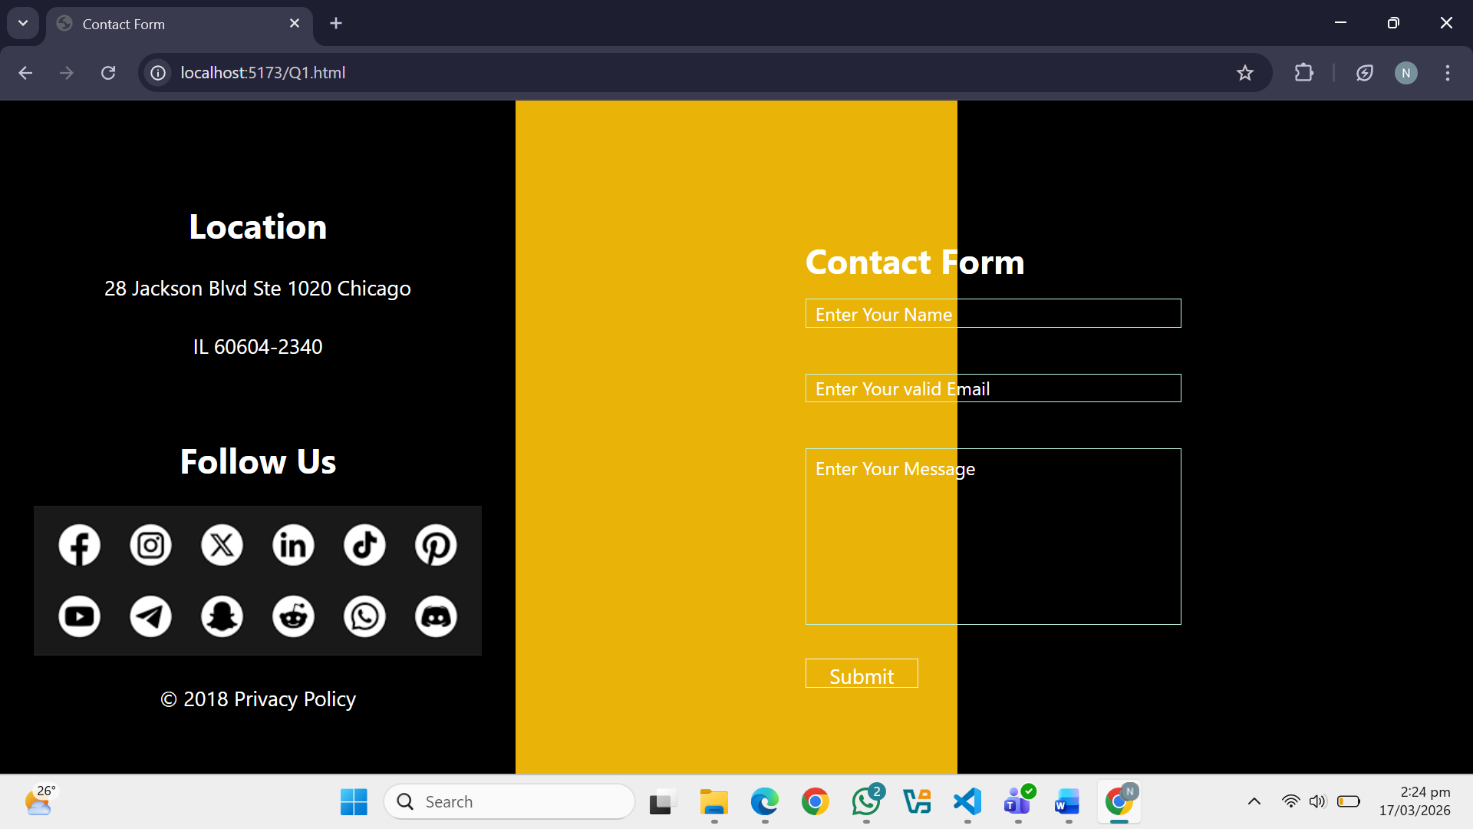
Question. No.2
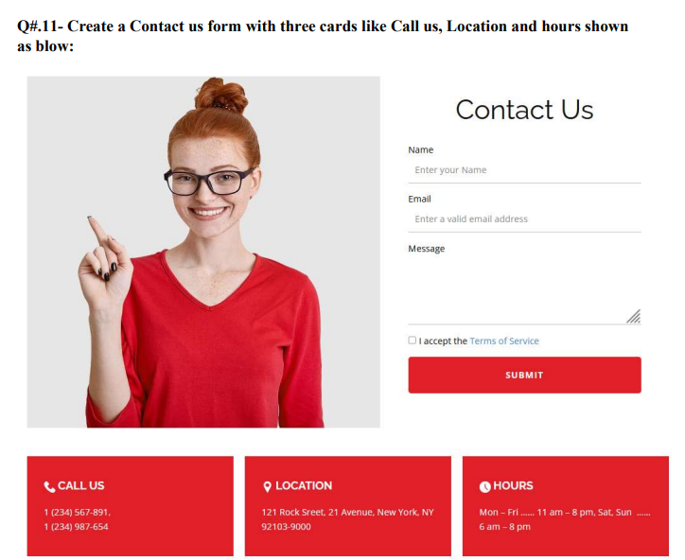
Code:
<!DOCTYPE html>
<html lang="en">
<head>
<meta charset="UTF-8">
<meta name="viewport" content="width=device-width, initial-scale=1.0">
<title>Contact Us</title>
<script src="https://cdn.tailwindcss.com"></script>
</head>
<body class="bg-gray-100 text-black">

<!-- HEADER -->
<header class="flex items-start p-6 gap-6">

<!-- Profile Image -->
<div class="w-100 h-100 flex-shrink-0">
<img src="Girl.jpg" class="w-full h-full object-cover"/>
</div>

<!-- Form -->
<div class="flex-1 max-w-xl ml-10">
<h1 class="text-3xl font-bold mb-6">Contact Us</h1>

<form class="flex flex-col gap-4">

<!-- Name -->
<div>
<label class="block mb-1 font-medium">Name:</label>
<input
type="text"
name="Name"
placeholder="Enter Your Name"
class="w-1/2 h-8 border-b-2 border-black bg-transparent outline-none px-1"
/>
</div>

<!-- Email -->
<div>
<label class="block mb-1 font-medium">Email:</label>
<input
type="email"
name="Email"
placeholder="Enter Your valid Email"
class="w-1/2 h-8 border-b-2 border-black bg-transparent outline-none px-1"
/>
</div>

<!-- Message -->
<div>
<label class="block mb-1 font-medium">Message:</label>
<textarea
name="Message"
rows="6"
placeholder="Enter Your Message"
class="w-full border-b-2 border-black bg-transparent outline-none px-1 resize-none"
></textarea>
</div>

<!-- Checkbox -->
<div class="flex items-center gap-2">
<input type="checkbox" class="w-4 h-4 accent-red-600 cursor-pointer"/>
<span class="text-sm">I agree to the terms and conditions</span>
</div>

<!-- Submit Button -->
<button
type="submit"
class="w-72 h-12 bg-red-600 text-white text-lg font-semibold border-2 border-red-600 rounded hover:bg-red-700 transition-colors duration-200"
>
Submit
</button>

</form>
</div>
</header>

<!-- SPACER -->
<section class="h-28"></section>

<!-- FOOTER -->
<footer class="text-white text-center">
<div class="flex justify-center">

<!-- Call Us -->
<div class="w-1/4 bg-red-600 py-6 px-4">
<img src="Phone.jpg" class="w-8 mx-auto mb-2"/>
<p class="text-xl font-bold">Call Us</p>
<p class="text-base mt-2">1(234)567891</p>
<p class="text-base">1(234)987654</p>
</div>

<!-- Location -->
<div class="w-1/4 bg-red-600 py-6 px-4">
<img src="Location.jpg" class="w-8 mx-auto mb-2"/>
<p class="text-xl font-bold">Location</p>
<p class="text-base mt-2">121 Rock Street, 21 Avenue, NewYork, NY</p>
<p class="text-base">92103-90000</p>
</div>

<!-- Hours -->
<div class="w-1/4 bg-red-600 py-6 px-4">
<img src="Clock.jpg" class="w-8 mx-auto mb-2"/>
<p class="text-xl font-bold">Hours</p>
<p class="text-base mt-2">Mon-Fri: 11am - 8pm</p>
<p class="text-base">Sat, Sun: 6pm - 8pm</p>
</div>
</div>
</footer>
</body>
</html>
Output:
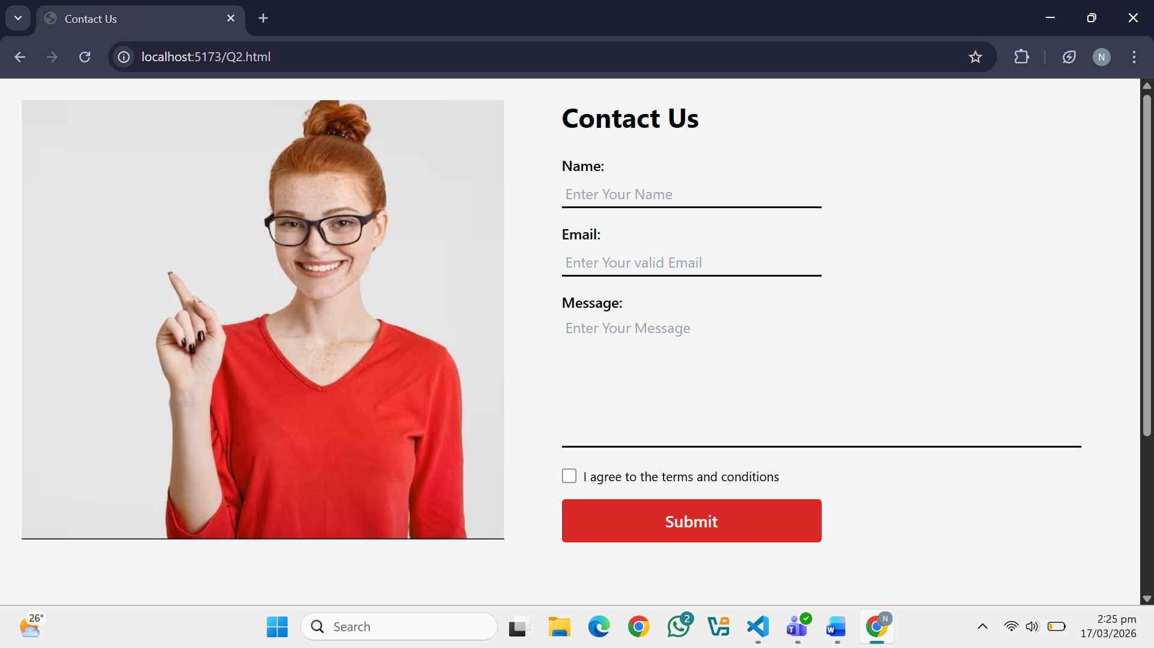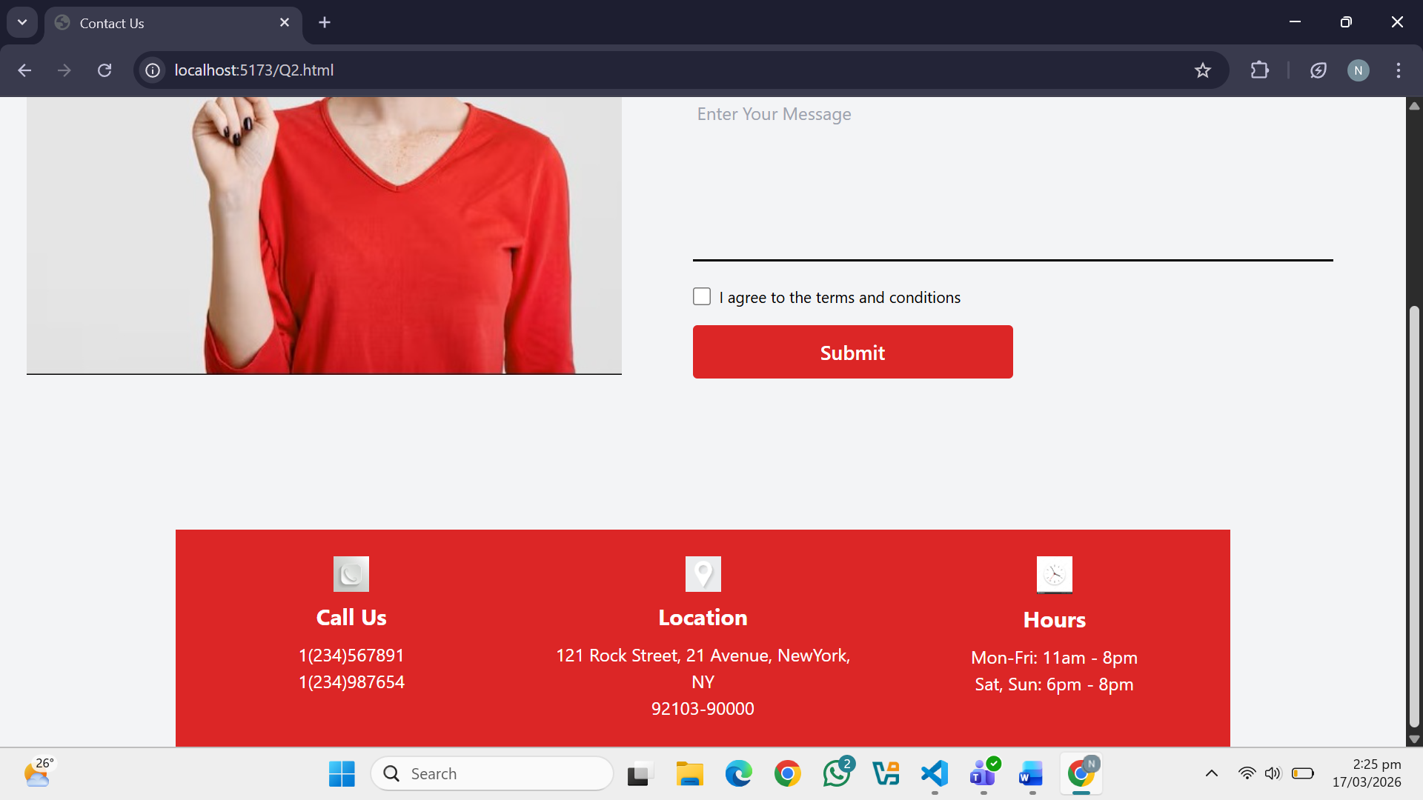
Question. No.3
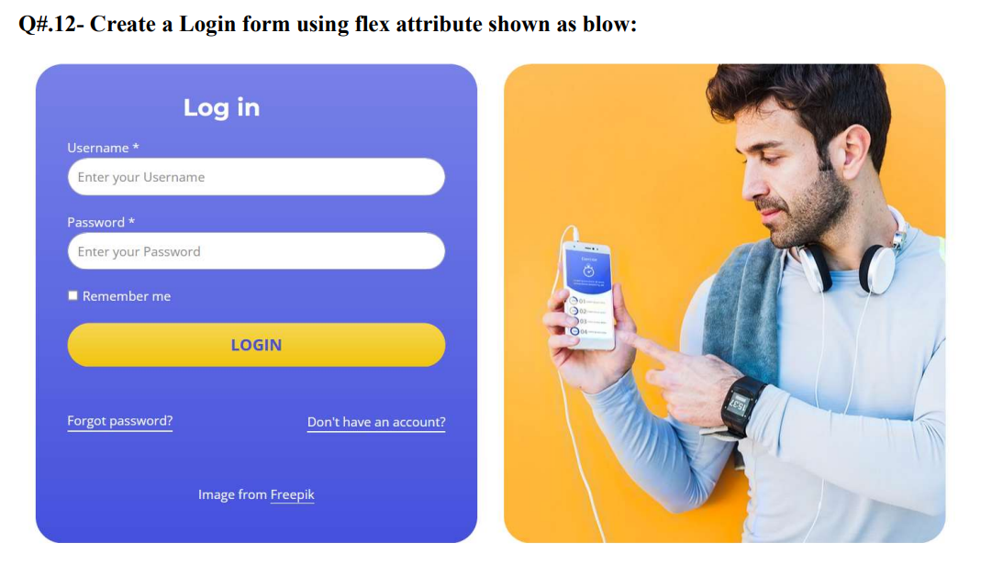
Code:
<!DOCTYPE html>
<html lang="en">
<head>
<meta charset="UTF-8">
<meta name="viewport" content="width=device-width, initial-scale=1.0">
<title>Login</title>
<script src="https://cdn.tailwindcss.com"></script>
</head>
<body class="bg-gray-100">

<form class="flex h-screen">

<!-- LEFT SIDE - Login Form -->
<div class="w-1/2 h-full bg-blue-900 text-white flex flex-col px-8 py-6">

<!-- Title -->
<h1 class="text-3xl font-bold text-center mt-4 mb-6">Log In</h1>

<!-- Username -->
<label class="mb-1 ml-1 text-sm font-medium">username*</label>
<input
type="text"
name="username"
placeholder="Enter Your Username"
class="w-4/5 h-8 bg-transparent border border-white text-white placeholder-white outline-none px-2 mb-4"
/>

<!-- Password -->
<label class="mb-1 ml-1 text-sm font-medium">password*</label>
<input
type="password"
name="password"
placeholder="Enter Your Password"
class="w-4/5 h-8 bg-transparent border border-white text-white placeholder-white outline-none px-2 mb-4"
/>

<!-- Remember Me -->
<div class="flex items-center gap-2 mb-4 ml-1">
<input
type="checkbox"
class="w-4 h-4 accent-yellow-400 cursor-pointer"
/>
<span class="text-sm">Remember me</span>
</div>

<!-- Login Button -->
<button
type="submit"
class="w-4/5 h-10 bg-yellow-400 text-blue-900 font-bold text-base border border-white hover:bg-yellow-300 transition-colors duration-200 ml-1"
>
Login
</button>

<!-- Links -->
<div class="flex justify-between w-4/5 mt-4 ml-1">
<a href="#" class="text-white text-sm hover:underline">Forget Password?</a>
<a href="#" class="text-white text-sm hover:underline">Don't have an account?</a>
</div>

<!-- Footer Note -->
<p class="text-center text-sm mt-auto pt-10">Image from Freepik</p>

</div>

<!-- RIGHT SIDE - Image -->
<div class="w-1/2 h-full">
<img
src="Boy.jpg"
class="w-full h-full object-cover"
/>
</div>

</form>

</body>
</html>
Output:
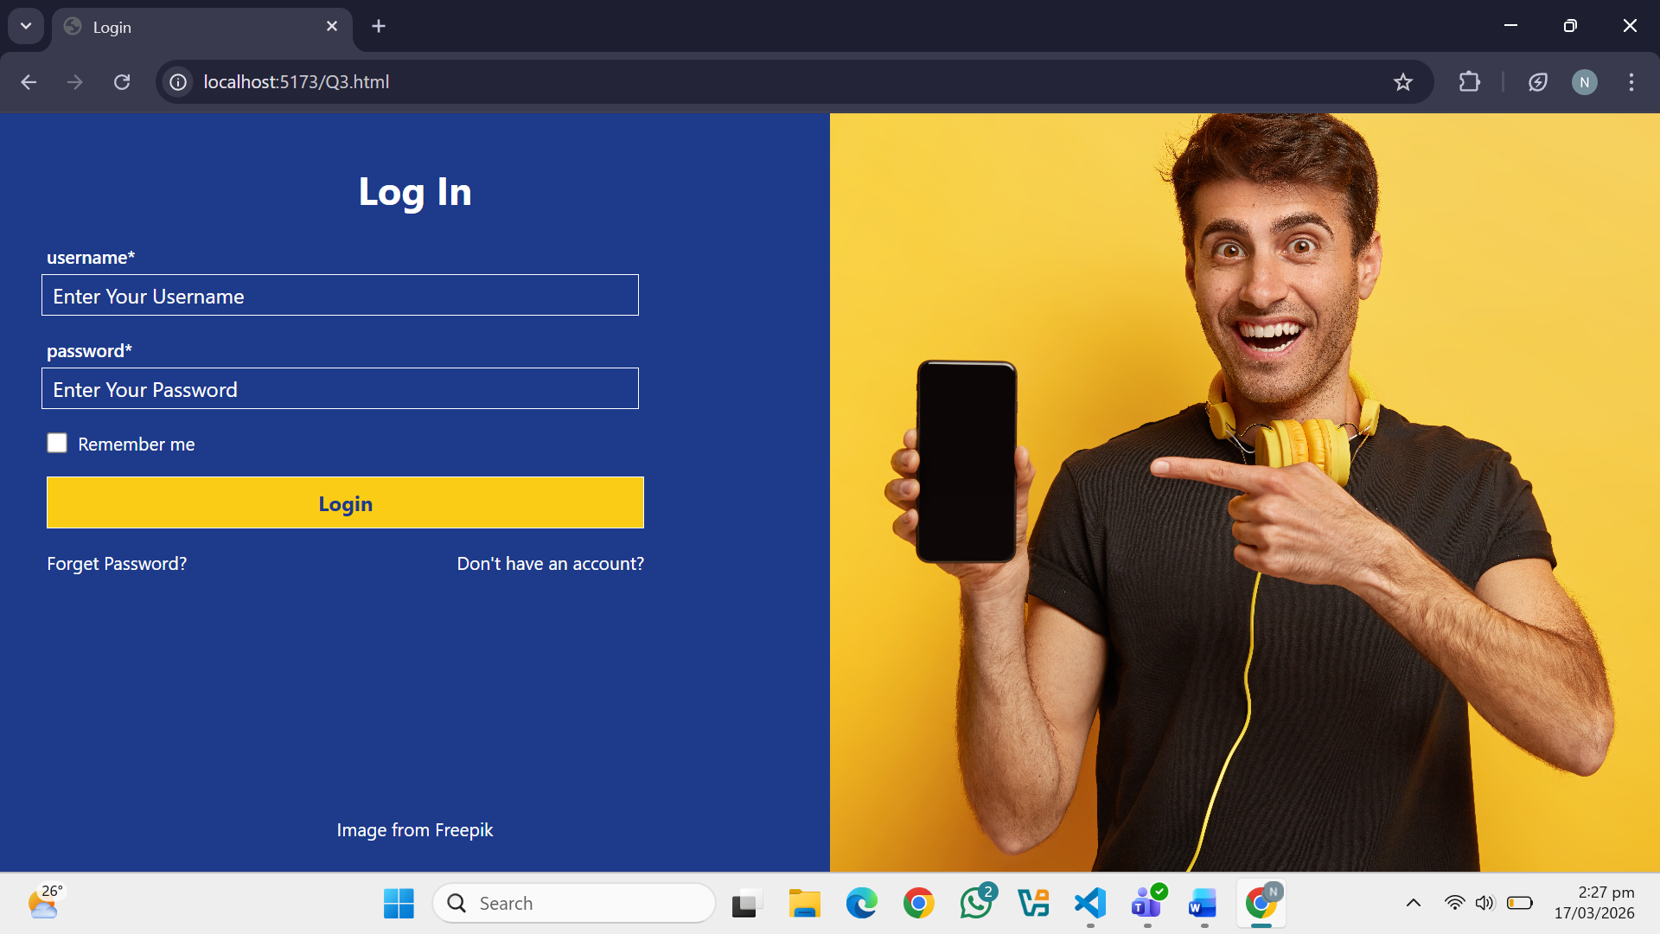
Question. No.4
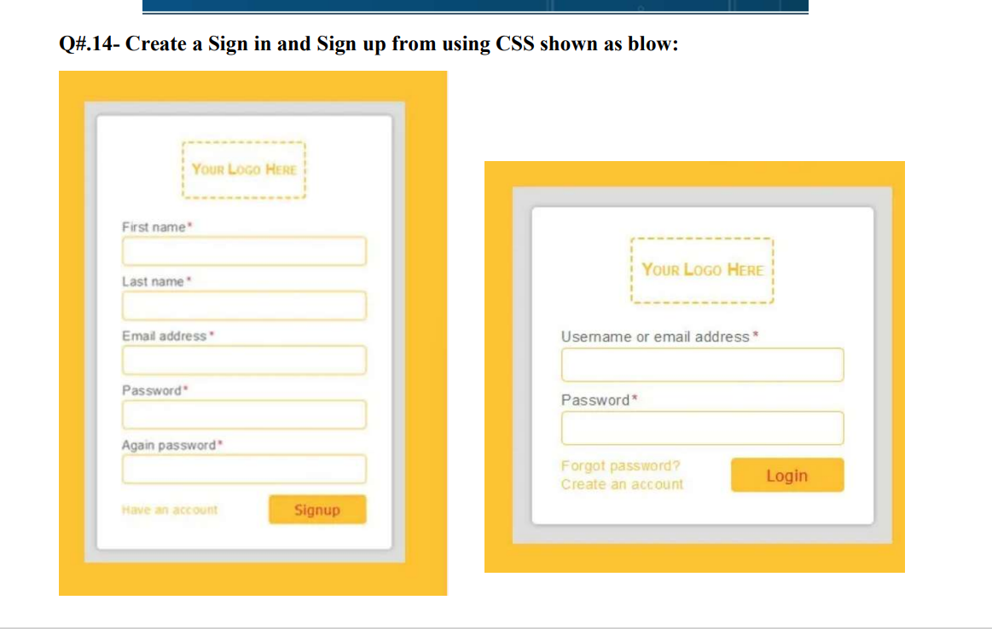
Code:
<!DOCTYPE html>
<html lang="en">
<head>
<meta charset="UTF-8">
<meta name="viewport" content="width=device-width, initial-scale=1.0">
<title>Signup / Login</title>
<script src="https://cdn.tailwindcss.com"></script>
</head>
<body class="font-sans bg-white p-6">

<div class="flex flex-wrap gap-6 justify-start items-start p-4">

<!-- SIGNUP FORM (LEFT) -->
<div class="bg-[#f2b632] p-8 rounded">
<div class="w-80 bg-gray-200 p-5 rounded">

<!-- Logo -->
<h3 class="text-center border-2 border-dashed border-[#f2b632] p-3 mb-4 font-bold">
Your Logo Here
</h3>

<!-- First Name -->
<p class="mb-1 text-sm font-medium">First name *</p>
<input type="text"
class="w-full h-8 px-2 border border-[#f2b632] bg-white outline-none mb-3"/>

<!-- Last Name -->
<p class="mb-1 text-sm font-medium">Last name *</p>
<input type="text"
class="w-full h-8 px-2 border border-[#f2b632] bg-white outline-none mb-3"/>

<!-- Email -->
<p class="mb-1 text-sm font-medium">Email address *</p>
<input type="text"
class="w-full h-8 px-2 border border-[#f2b632] bg-white outline-none mb-3"/>

<!-- Password -->
<p class="mb-1 text-sm font-medium">Password *</p>
<input type="password"
class="w-full h-8 px-2 border border-[#f2b632] bg-white outline-none mb-3"/>

<!-- Again Password -->
<p class="mb-1 text-sm font-medium">Again password *</p>
<input type="password"
class="w-full h-8 px-2 border border-[#f2b632] bg-white outline-none mb-4"/>

<!-- Bottom Row -->
<div class="flex justify-between items-center mt-2">
<span class="text-[#f2b632] text-sm font-medium">Have an account</span>
<button type="button"
class="bg-[#f2b632] text-white border-none px-5 py-2 hover:bg-yellow-500 transition-colors duration-200">
Signup
</button>
</div>

</div>
</div>

<!-- LOGIN FORM (RIGHT) -->
<div class="bg-[#f2b632] p-8 rounded">
<div class="w-80 bg-gray-200 p-5 rounded">

<!-- Logo -->
<h3 class="text-center border-2 border-dashed border-[#f2b632] p-3 mb-4 font-bold">
Your Logo Here
</h3>

<!-- Username -->
<p class="mb-1 text-sm font-medium">Username or email address *</p>
<input type="text"
class="w-full h-8 px-2 border border-[#f2b632] bg-white outline-none mb-3"/>

<!-- Password -->
<p class="mb-1 text-sm font-medium">Password *</p>
<input type="password"
class="w-full h-8 px-2 border border-[#f2b632] bg-white outline-none mb-4"/>

<!-- Bottom Row -->
<div class="flex justify-between items-center mt-2">
<span class="text-[#f2b632] text-sm font-medium leading-6">
Forgot password?<br/>Create an account
</span>
<button type="button"
class="bg-[#f2b632] text-white border-none px-5 py-2 hover:bg-yellow-500 transition-colors duration-200">
Login
</button>
</div>
</div>
</div>
</div>
</body>
</html>
Output:
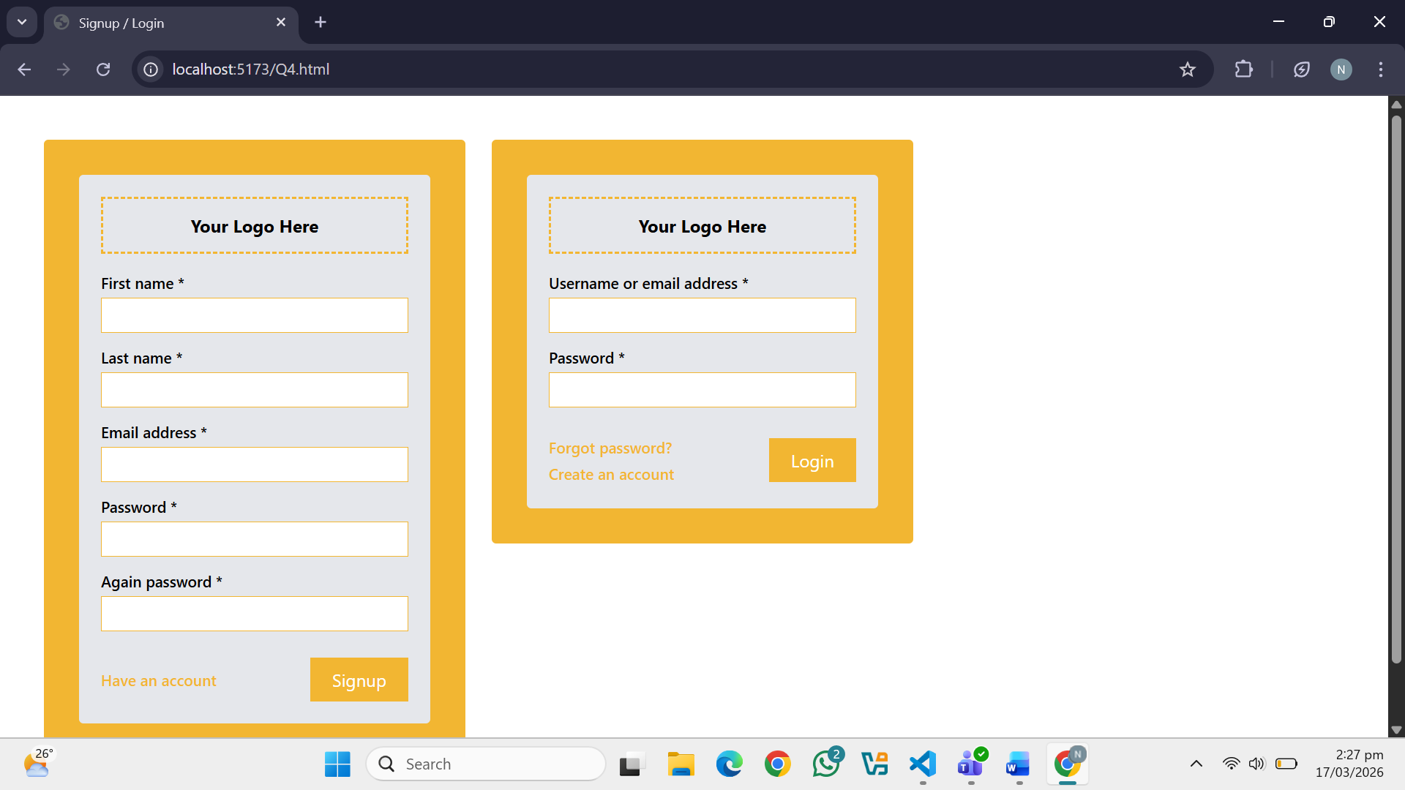
Question. No.5
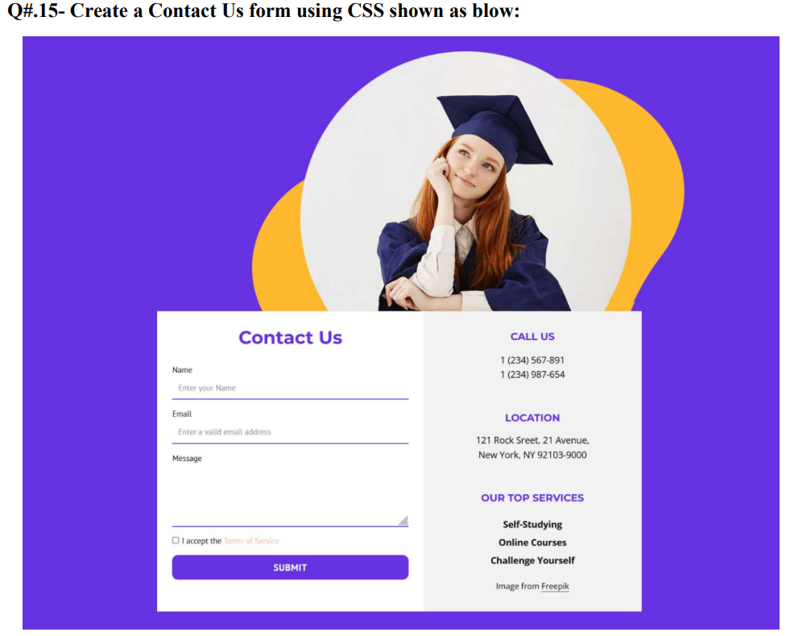
Code:
<!DOCTYPE html>
<html>
<head>
<title>Contact Us</title>
<script src="https://cdn.tailwindcss.com"></script>
</head>

<body class="m-0 font-sans bg-gradient-to-r from-[#6a3dd9] to-[#5b2bd1] min-h-screen">

<!-- TOP SECTION -->
<div class="relative text-center pt-16 pb-10">

<!-- Yellow Circle 1 -->
<div class="absolute w-[220px] h-[220px] bg-[#f7b733] rounded-full top-[100px] left-[30%] z-0"></div>

<!-- Yellow Circle 2 -->
<div class="absolute w-[220px] h-[220px] bg-[#f7b733] rounded-full top-[80px] left-[55%] z-0"></div>

<!-- Image -->
<img src="Scholar.jpg" class="w-[250px] h-[250px] rounded-full relative z-10 object-cover inline-block">

</div>

<!-- CONTAINER -->
<div class="w-[800px] mx-auto mt-10 bg-[#eeeeee] flex">

<!-- LEFT SIDE -->
<div class="w-1/2 p-8">
<h2 class="text-[#6a3dd9] text-2xl font-bold mb-4">Contact Us</h2>

<div class="mb-3">
<label class="text-gray-700 text-sm">Name</label>
<input type="text" placeholder="Enter your name"
class="w-full border-0 border-b-2 border-[#6a3dd9] bg-transparent mt-1 mb-3 p-2 outline-none focus:border-purple-900"/>
</div>

<div class="mb-3">
<label class="text-gray-700 text-sm">Email</label>
<input type="email" placeholder="Enter a valid email address"
class="w-full border-0 border-b-2 border-[#6a3dd9] bg-transparent mt-1 mb-3 p-2 outline-none focus:border-purple-900"/>
</div>

<div class="mb-3">
<label class="text-gray-700 text-sm">Message</label>
<textarea rows="4"
class="w-full border-0 border-b-2 border-[#6a3dd9] bg-transparent mt-1 mb-3 p-2 outline-none focus:border-purple-900 resize-none"></textarea>
</div>

<div class="flex items-center gap-2 mb-4">
<input type="checkbox" class="accent-[#6a3dd9] w-4 h-4"/>
<span class="text-sm text-gray-700">I accept the Terms of Service</span>
</div>

<button class="w-full py-3 bg-[#6a3dd9] text-white border-0 rounded-md hover:bg-purple-900 transition-colors font-semibold tracking-wide">
SUBMIT
</button>
</div>

<!-- RIGHT SIDE -->
<div class="w-1/2 p-8 bg-[#dddddd] text-center">

<h4 class="text-[#6a3dd9] font-bold text-lg mb-1">CALL US</h4>
<p class="text-gray-700 mb-5 text-sm">1 (234) 567-891<br>1 (234) 987-654</p>

<h4 class="text-[#6a3dd9] font-bold text-lg mb-1">LOCATION</h4>
<p class="text-gray-700 mb-5 text-sm">121 Rock Street, 21 Avenue,<br>New York, NY</p>

<h4 class="text-[#6a3dd9] font-bold text-lg mb-1">OUR TOP SERVICES</h4>
<p class="text-gray-700 text-sm">Self-Studying<br>Online Courses<br>Challenge Yourself</p>

</div>
</div>

</body>
</html>
Output:
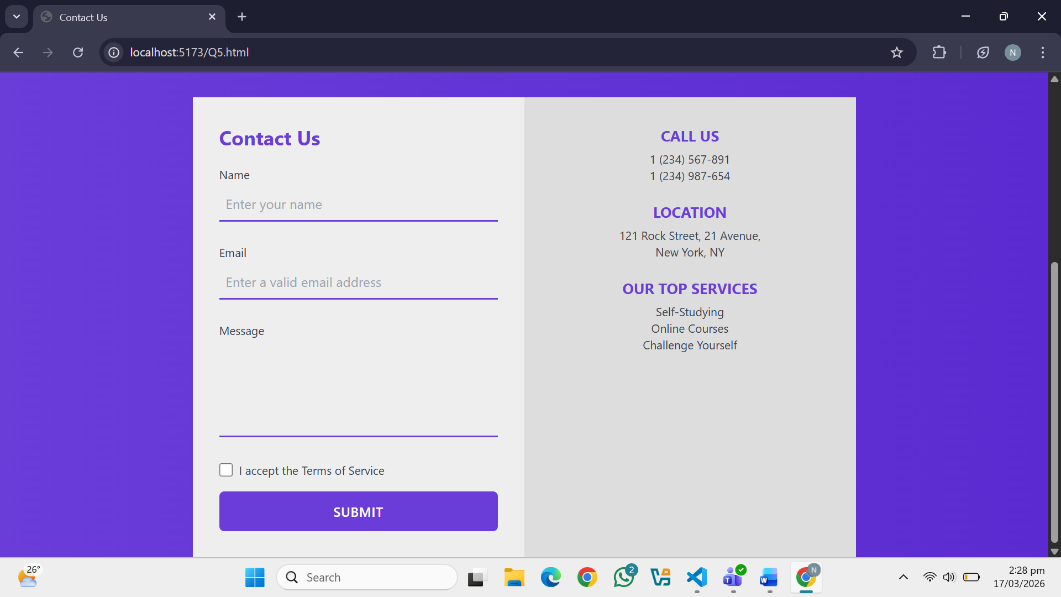
Question. No.6
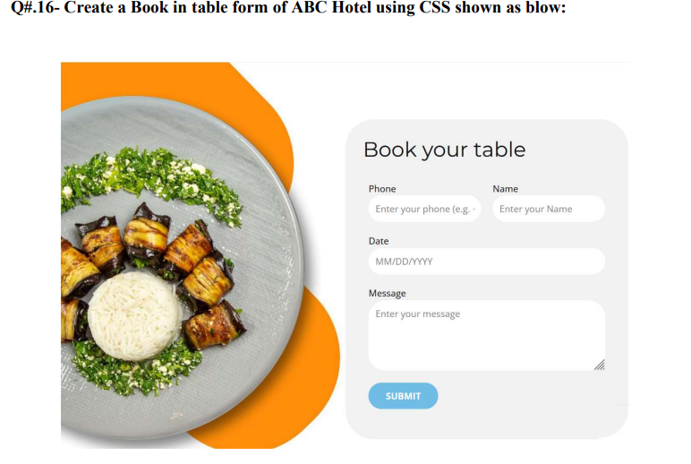
Code:
<!DOCTYPE html>
<html lang="en">
<head>
<meta charset="UTF-8">
<meta name="viewport" content="width=device-width, initial-scale=1.0">
<title>ABC Hotel - Book Your Table</title>
<script src="https://cdn.tailwindcss.com"></script>
</head>
<body class="bg-white min-h-screen flex items-center justify-center p-10">

<!-- MAIN WRAPPER -->
<div class="flex items-center justify-center gap-0 w-full max-w-5xl">

<!-- LEFT SIDE - IMAGE WITH ORANGE CIRCLES -->
<div class="relative w-[500px] h-[500px] flex-shrink-0">

<!-- Orange Circle TOP RIGHT -->
<div class="absolute w-72 h-72 bg-orange-500 rounded-full top-0 right-16 z-0"></div>

<!-- Orange Circle BOTTOM LEFT -->
<div class="absolute w-72 h-72 bg-orange-500 rounded-full bottom-0 left-8 z-0"></div>

<!-- Food Image CENTER -->
<img
src="food.png"
alt="Food"
class="absolute w-72 h-72 rounded-full object-cover z-10
top-1/2 left-1/2 -translate-x-1/2 -translate-y-1/2
shadow-xl"
/>

</div>

<!-- RIGHT SIDE - BOOKING FORM CARD -->
<div class="bg-gray-100 rounded-3xl p-8 w-[480px] shadow-md flex-shrink-0">

<!-- Title -->
<h1 class="text-4xl font-light text-gray-800 mb-6">Book your table</h1>

<!-- Phone + Name Row -->
<div class="flex gap-4 mb-4">

<!-- Phone -->
<div class="flex-1">
<label class="block text-sm text-gray-600 mb-1">Phone</label>
<input
type="tel"
placeholder="Enter your phone (e.g. +1...)"
class="w-full px-4 py-2 rounded-xl bg-white border-none outline-none text-sm text-gray-400 shadow-sm"
/>
</div>

<!-- Name -->
<div class="flex-1">
<label class="block text-sm text-gray-600 mb-1">Name</label>
<input
type="text"
placeholder="Enter your Name"
class="w-full px-4 py-2 rounded-xl bg-white border-none outline-none text-sm text-gray-400 shadow-sm"
/>
</div>

</div>

<!-- Date -->
<div class="mb-4">
<label class="block text-sm text-gray-600 mb-1">Date</label>
<input
type="date"
class="w-full px-4 py-2 rounded-xl bg-white border-none outline-none text-sm text-gray-400 shadow-sm"
/>
</div>

<!-- Message -->
<div class="mb-6">
<label class="block text-sm text-gray-600 mb-1">Message</label>
<textarea
rows="4"
placeholder="Enter your message"
class="w-full px-4 py-2 rounded-xl bg-white border-none outline-none text-sm text-gray-400 shadow-sm resize-none"
></textarea>
</div>

<!-- Submit Button -->
<button
type="submit"
class="px-10 py-3 bg-[#4ab8d8] hover:bg-sky-400 active:scale-95 text-white font-bold text-sm rounded-full tracking-widest transition-all duration-200 shadow-md"
>
SUBMIT
</button>

</div>
</div>

</body>
</html>
Output:
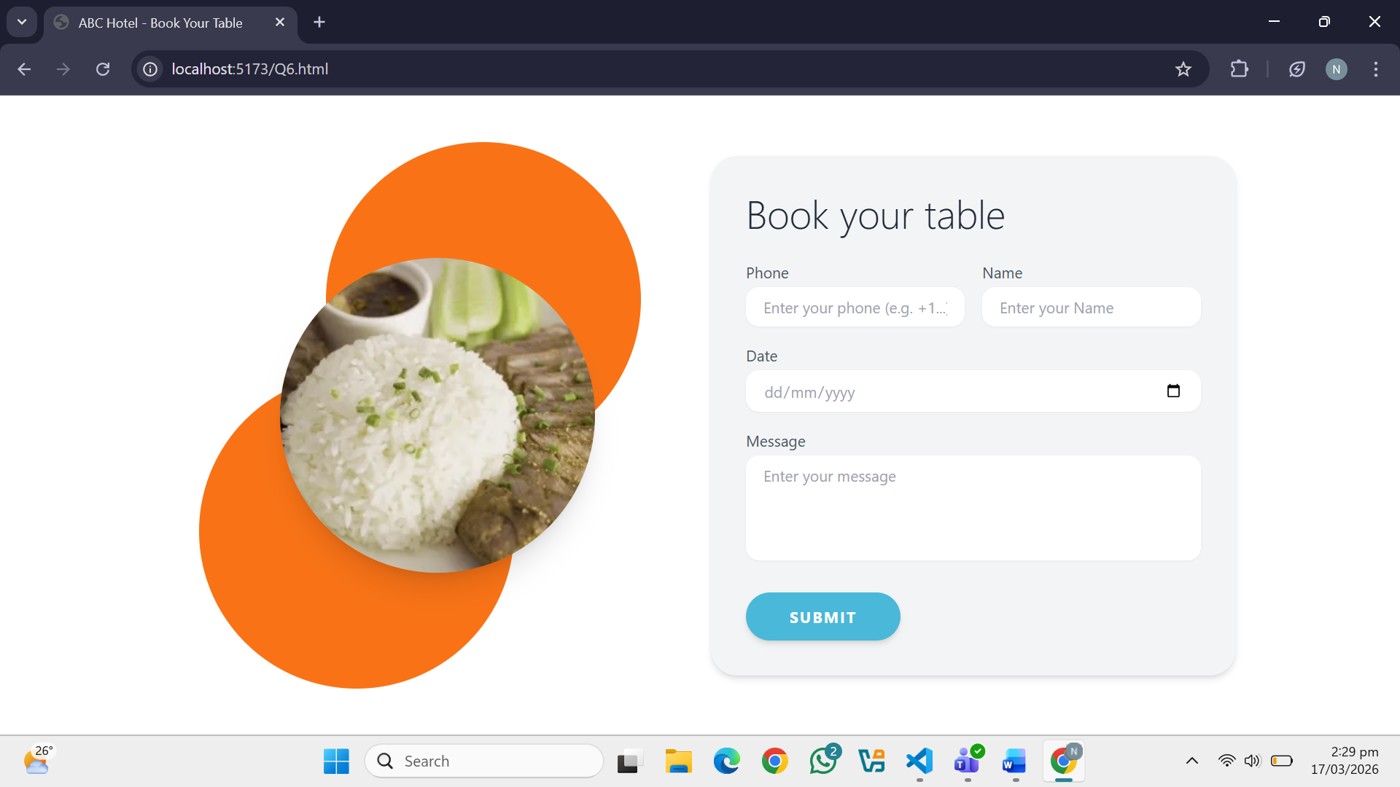
Question. No.7
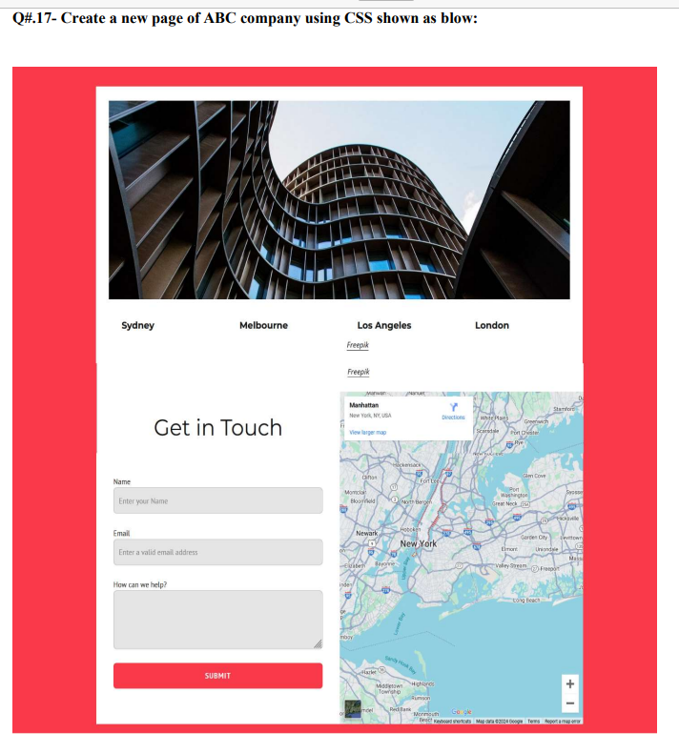
Code:
<!DOCTYPE html>
<html lang="en">
<head>
<meta charset="UTF-8">
<meta name="viewport" content="width=device-width, initial-scale=1.0">
<title>ABC Company</title>
<script src="https://cdn.tailwindcss.com"></script>
</head>
<body class="bg-red-500 font-sans m-0">

<!-- MAIN WHITE BOX -->
<div class="w-[900px] mx-auto my-12 bg-white p-8">

<!-- TOP IMAGE -->
<div>
<img src="Building.png" class="w-full h-72 object-cover"/>
</div>

<!-- CITY NAMES -->
<div class="flex justify-around my-5 font-bold text-base">
<div>Sydney</div>
<div>Melbourne</div>
<div>Los Angeles</div>
<div>London</div>
</div>

<!-- BOTTOM SECTION -->
<div class="flex mt-8 gap-6">

<!-- FORM -->
<div class="w-1/2 pr-5">
<h2 class="text-3xl font-bold mb-5">Get in Touch</h2>

<!-- Name -->
<div class="mb-3">
<label class="block text-sm font-medium mb-1">Name</label>
<input
type="text"
placeholder="Enter your Name"
class="w-full px-3 py-2 border border-gray-300 rounded outline-none focus:border-red-500 transition-colors"
/>
</div>

<!-- Email -->
<div class="mb-3">
<label class="block text-sm font-medium mb-1">Email</label>
<input
type="email"
placeholder="Enter a valid email address"
class="w-full px-3 py-2 border border-gray-300 rounded outline-none focus:border-red-500 transition-colors"
/>
</div>

<!-- Message -->
<div class="mb-4">
<label class="block text-sm font-medium mb-1">How can we help?</label>
<textarea
rows="5"
class="w-full px-3 py-2 border border-gray-300 rounded outline-none focus:border-red-500 transition-colors resize-none"
></textarea>
</div>

<!-- Submit Button -->
<button
type="submit"
class="w-full py-3 bg-red-500 text-white font-bold rounded hover:bg-red-600 active:scale-95 transition-all duration-200"
>
SUBMIT
</button>
</div>

<!-- MAP -->
<div class="w-1/2">
<img src="Map.jpg" class="w-full h-[350px] object-cover rounded"/>
</div>

</div>
</div>

</body>
</html>
Output:
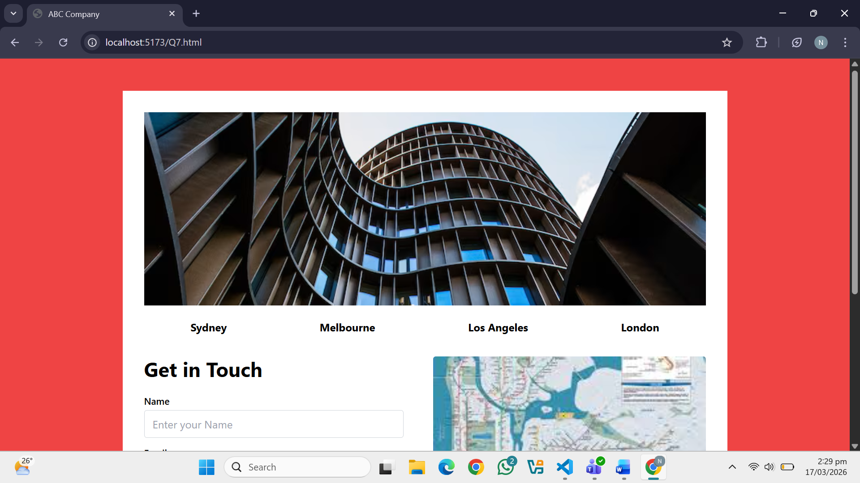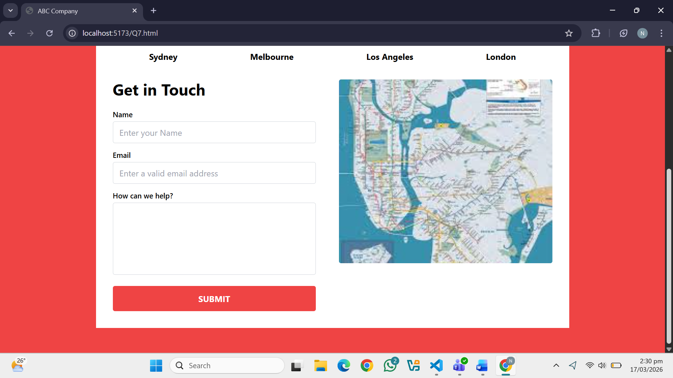
Question. No.8
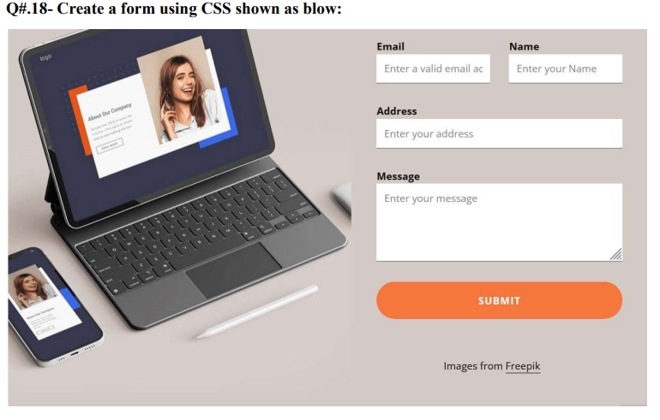
Code:
<!DOCTYPE html>
<html lang="en">
<head>
<meta charset="UTF-8">
<meta name="viewport" content="width=device-width, initial-scale=1.0">
<title>Contact Form</title>
<script src="https://cdn.tailwindcss.com"></script>
</head>
<body class="font-sans bg-[#d8d1cd] min-h-screen">

<!-- MAIN CONTAINER -->
<div class="w-[800px] mx-auto mt-10 flex gap-8 items-start">

<!-- LEFT - IMAGE -->
<div class="flex-shrink-0">
<img src="Laptop.jpg" class="w-[350px] rounded"/>
</div>

<!-- RIGHT - FORM -->
<div class="w-[350px]">
<form class="flex flex-col">

<!-- Email + Name Row -->
<div class="flex gap-3 mb-1">

<!-- Email -->
<div class="flex-1">
<label class="block text-sm font-medium text-gray-700 mb-1">Email</label>
<input
type="email"
placeholder="Enter a valid email"
class="w-full px-3 py-2 border border-gray-300 bg-white outline-none focus:border-orange-400 transition-colors mb-4"
/>
</div>

<!-- Name -->
<div class="flex-1">
<label class="block text-sm font-medium text-gray-700 mb-1">Name</label>
<input
type="text"
placeholder="Enter your Name"
class="w-full px-3 py-2 border border-gray-300 bg-white outline-none focus:border-orange-400 transition-colors mb-4"
/>
</div>

</div>

<!-- Address -->
<label class="block text-sm font-medium text-gray-700 mb-1">Address</label>
<input
type="text"
placeholder="Enter your address"
class="w-full px-3 py-2 border border-gray-300 bg-white outline-none focus:border-orange-400 transition-colors mb-4"
/>

<!-- Message -->
<label class="block text-sm font-medium text-gray-700 mb-1">Message</label>
<textarea
rows="4"
placeholder="Enter your message"
class="w-full px-3 py-2 border border-gray-300 bg-white outline-none focus:border-orange-400 transition-colors mb-4 resize-none"
></textarea>

<!-- Submit Button -->
<button
type="submit"
class="w-full py-3 bg-[#f47a3c] hover:bg-orange-500 active:scale-95 text-white font-bold border-none rounded-full tracking-wider transition-all duration-200"
>
SUBMIT
</button>

</form>
</div>

</div>

</body>
</html>
Output:
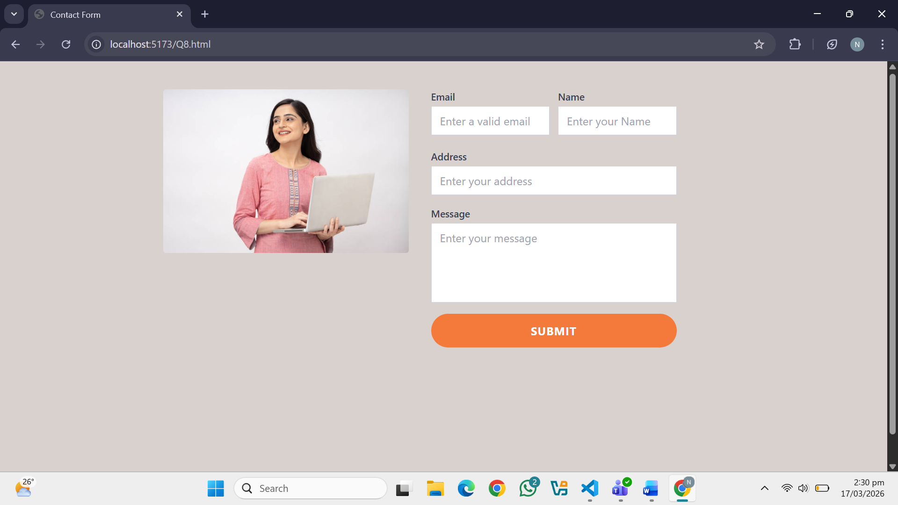
Question. No.9
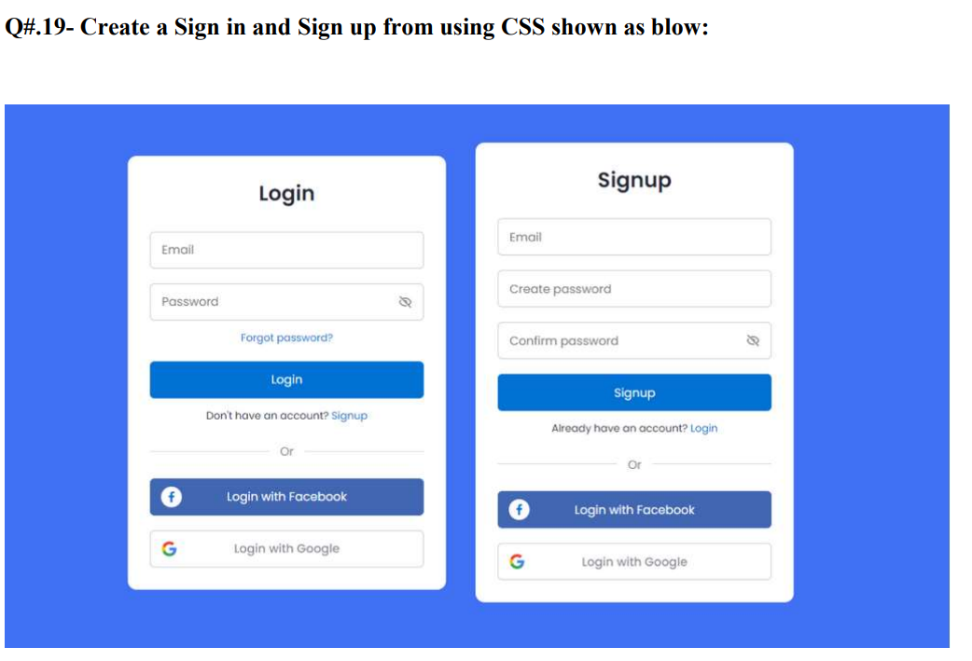
Code:
<!DOCTYPE html>
<html lang="en">
<head>
<meta charset="UTF-8">
<meta name="viewport" content="width=device-width, initial-scale=1.0">
<title>Login Signup</title>
<script src="https://cdn.tailwindcss.com"></script>
</head>
<body class="font-sans bg-[#3f6edb] min-h-screen">

<!-- CONTAINER -->
<div class="flex justify-center gap-10 mt-20 pb-10">

<!-- LOGIN BOX -->
<div class="bg-white p-5 w-64 rounded-xl shadow-md">

<h3 class="text-center font-bold text-lg mb-2">Login</h3>

<!-- Inputs -->
<input type="email" placeholder="Email"
class="w-full px-3 py-2 my-2 border border-gray-300 rounded outline-none focus:border-blue-500"/>

<input type="password" placeholder="Password"
class="w-full px-3 py-2 my-2 border border-gray-300 rounded outline-none focus:border-blue-500"/>

<!-- Login Button -->
<button class="w-full py-2 mt-1 bg-[#1e73be] text-white rounded hover:bg-blue-700 transition-colors duration-200">
Login
</button>

<!-- Or -->
<p class="text-center text-sm my-2 text-gray-500">Or</p>

<!-- Facebook Button -->
<button class="w-full py-2 bg-[#3b5998] text-white rounded hover:opacity-90 transition-opacity duration-200 mb-2">
Login with Facebook
</button>

<!-- Google Button -->
<button class="w-full py-2 bg-[#db4437] text-white rounded hover:opacity-90 transition-opacity duration-200">
Login with Google
</button>

</div>

<!-- SIGNUP BOX -->
<div class="bg-white p-5 w-64 rounded-xl shadow-md">

<h3 class="text-center font-bold text-lg mb-2">Signup</h3>

<!-- Inputs -->
<input type="email" placeholder="Email"
class="w-full px-3 py-2 my-2 border border-gray-300 rounded outline-none focus:border-blue-500"/>

<input type="password" placeholder="Create password"
class="w-full px-3 py-2 my-2 border border-gray-300 rounded outline-none focus:border-blue-500"/>

<input type="password" placeholder="Confirm password"
class="w-full px-3 py-2 my-2 border border-gray-300 rounded outline-none focus:border-blue-500"/>

<!-- Signup Button -->
<button class="w-full py-2 mt-1 bg-[#1e73be] text-white rounded hover:bg-blue-700 transition-colors duration-200">
Signup
</button>

<!-- Or -->
<p class="text-center text-sm my-2 text-gray-500">Or</p>

<!-- Facebook Button -->
<button class="w-full py-2 bg-[#3b5998] text-white rounded hover:opacity-90 transition-opacity duration-200 mb-2">
Login with Facebook
</button>

<!-- Google Button -->
<button class="w-full py-2 bg-[#db4437] text-white rounded hover:opacity-90 transition-opacity duration-200">
Login with Google
</button>
</div>
</div>
</body>
</html>
Output:
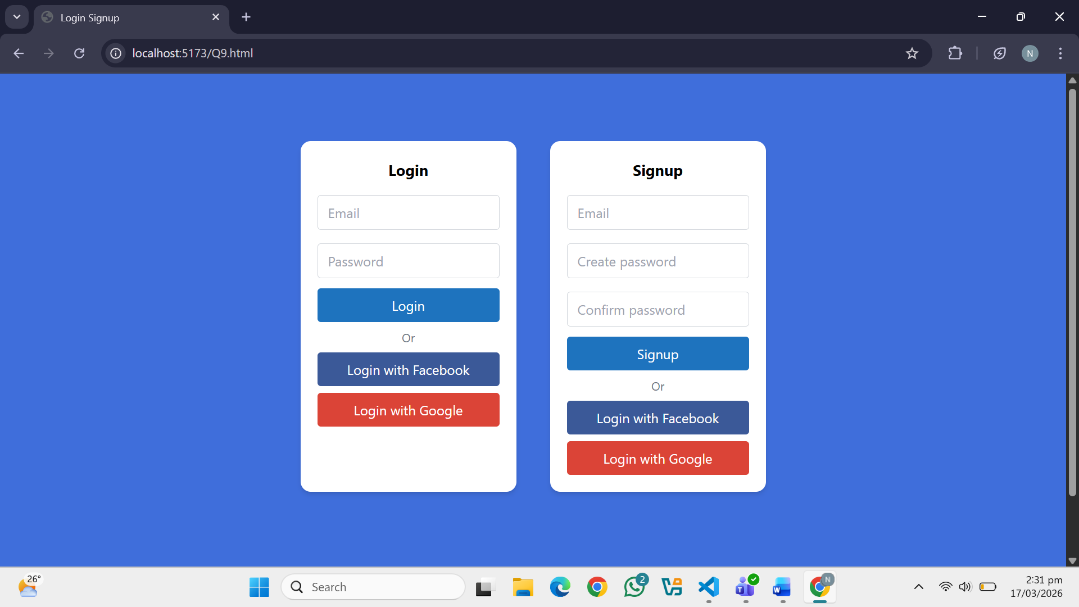
Question. No.10
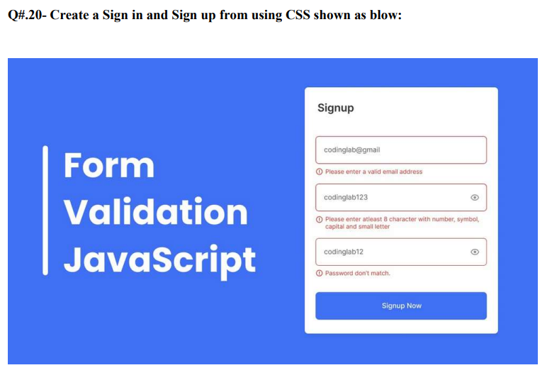
Code:
<!DOCTYPE html>
<html lang="en">
<head>
<meta charset="UTF-8">
<meta name="viewport" content="width=device-width, initial-scale=1.0">
<title>Form Validation</title>
<script src="https://cdn.tailwindcss.com"></script>

<script>
function validateForm() {

let email = document.getElementById("email").value;
let pass = document.getElementById("pass").value;
let cpass = document.getElementById("cpass").value;

let emailError = "";
let passError = "";
let cpassError = "";

if (!email.includes("@")) {
emailError = "Please enter a valid email address";
}

if (pass.length < 8) {
passError = "Password must be at least 8 characters";
}

if (pass !== cpass) {
cpassError = "Passwords don't match";
}

document.getElementById("emailError").innerHTML = emailError;
document.getElementById("passError").innerHTML = passError;
document.getElementById("cpassError").innerHTML = cpassError;

if (emailError === "" && passError === "" && cpassError === "") {
alert("Form Submitted Successfully!");
return true;
}

return false;
}
</script>

</head>
<body class="font-sans bg-[#4a73d9] min-h-screen">

<!-- CONTAINER -->
<div class="flex justify-around items-center mt-20 px-6">

<!-- LEFT TEXT -->
<div class="text-white text-5xl font-bold leading-tight">
Form<br/>
Validation<br/>
JavaScript
</div>

<!-- FORM BOX -->
<div class="bg-white p-6 w-80 rounded-lg shadow-lg">

<h3 class="text-xl font-bold mb-4">Signup</h3>

<form onsubmit="return validateForm()">

<!-- Email -->
<input
type="text"
id="email"
placeholder="Enter Email"
class="w-full px-3 py-2 my-2 border border-gray-300 rounded outline-none focus:border-[#4a73d9] transition-colors"
/>
<div id="emailError" class="text-red-500 text-xs mb-1"></div>

<!-- Password -->
<input
type="password"
id="pass"
placeholder="Enter Password"
class="w-full px-3 py-2 my-2 border border-gray-300 rounded outline-none focus:border-[#4a73d9] transition-colors"
/>
<div id="passError" class="text-red-500 text-xs mb-1"></div>

<!-- Confirm Password -->
<input
type="password"
id="cpass"
placeholder="Confirm Password"
class="w-full px-3 py-2 my-2 border border-gray-300 rounded outline-none focus:border-[#4a73d9] transition-colors"
/>
<div id="cpassError" class="text-red-500 text-xs mb-1"></div>

<br/>

<!-- Submit Button -->
<button
type="submit"
class="w-full py-3 bg-[#4a73d9] text-white font-semibold rounded hover:bg-blue-700 active:scale-95 transition-all duration-200"
>
Signup Now
</button>

</form>
</div>
</div>

</body>
</html>
Output:
